SOFTWARE ARCHITECTURE
AND DESIGN SPECIFICATION
Project Management System (PMS)
Group 4 Semester-5 Section - I
PES2UG24CS514 | SPHOORTHI PULIPATI
PES2UG24CS512 | SOWMYA RAMESH
PES2UG24CS550 | TANISHA DALMIA
PES2UG24CS532 | SUHAS PRUSTY

Document field | Value
Version | 1.0
Date | 09 October 2026
Status | Draft for team review
Prepared by | PMS Project Team
Primary source | Software Requirements Specification (SRS)
Testing reference | PMS test case identifiers referenced in the SRS; detailed standalone test plan was not available with the supplied template

Purpose: describe a practical architecture and design that supports the PMS requirements and their linked verification tests.

Revision History
Version | Date | Author | Change Summary
1.0 | 09-10-2026 | PMS Project Team - 4 | Initial PMS-specific architecture and design based on SRS requirements and test references.
1.1 | 10-10-2026 | PMS Project Team - 4 | Made changes to the Architecture and Design based on discussions

Approvals
Role | Name | Signature / Date
Course Coordinator | Professor. Nivedita
Project Manager | Tanisha Dalmia
Developer | Sowmya Ramesh
Test Engineer | Suhas Prusty
QA Lead | Sphoorthi Pulipati

1. Introduction

1.1 Purpose
This Software Architecture and Design Specification (SAD) describes the proposed architecture, major components, interfaces, data responsibilities, security controls, and design flows for the Project Management System (PMS). It translates the SRS into a design that can be implemented and verified by the project team.

1.2 Scope
The PMS is a web-based application for user authentication and administration, project and member management, task management, milestones, a project dashboard, comments, basic project reports, and audit logging. With role-based access, different team members can edit required parts of the project management system.

1.3 Audience
Developers, Test Engineer, QA Lead, Project Manager, system administrators, and assessment evaluators. I.e.-Software Development Team Members

1.4 Definitions
Term | Meaning
PMS | Project Management System
SRS / SAD | Software Requirements Specification / Software Architecture and Design Specification
FR / NFR | Functional Requirement / Non-functional Requirement
RBAC | Role-Based Access Control
CRUD | Create, Read, Update, Delete
RTM | Requirements Traceability Matrix
UI / API / DB | User Interface / Application Programming Interface / Database

2. Document Overview

2.1 How to use this document
Sections 3 explains the Architecture of the project including goals, constraints and modules. Section 4 explains the Design with the key flows, API interface design and also the UI/UX component. Section 5 is the quality requirements and verification.

2.2 Related Documents
- Project Management System Software Requirements Specification (SRS), Version 1.0.
- Project Management System Test Plan
- Requirements Traceability Matrix (RTM) as contained in SRS

3. Architecture

3.1 Goals and Constraints
- Provide a clear, browser-based interface for project and task workflows.
- Enforce authentication and role permissions on protected operations.
- Persist user, project, task, milestone, comment, and audit information correctly.
- Keep components modular and maintain basic documentation to support maintainability.
- Support the SRS completion constraint of approximately three weeks by focusing on core functionality.
- Use DB for persistent storage, as specified in the SRS.

3.2 Stakeholders and Concerns
Stakeholder | Primary concerns
Admin | User account administration, secure access, accountability.
Project Manager | Projects, members, tasks, milestones, progress, and reports.
Team Member | Assigned work, task status updates, and task comments.
Developer | Modularity, implementability, data integrity, and maintainability.
Test Engineer | Traceable, repeatable tests for functional and quality requirements.
QA Lead | Requirement coverage, defect verification, and release quality.

3.3 Logical Component Diagram
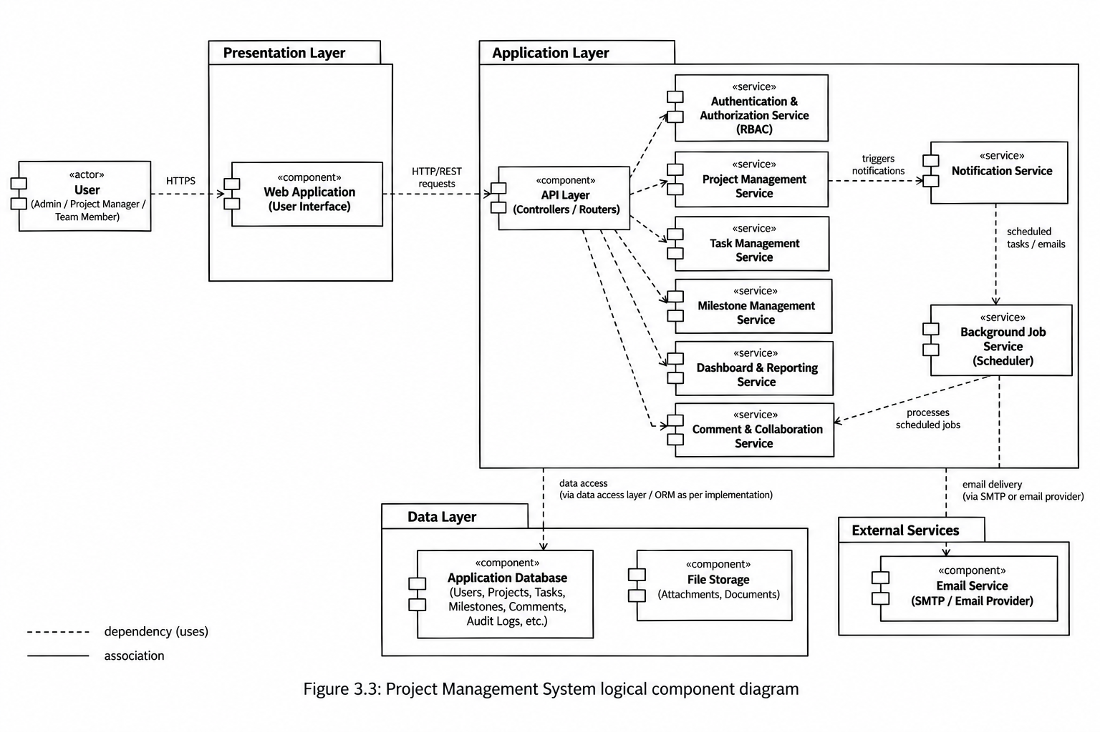

3.4 Component Descriptions
Component | Responsibilities | Related requirements / tests
Web UI | Login, dashboard, project pages, task list/board, milestone section, comments, user management, reports, and clear error feedback. | FR-01, FR-02, FR-16, FR-17; TC-Auth, TC-Dash, TC-Report, TC-UX
Authentication and Session | Validate credentials, establish and end authenticated sessions, and reject unauthenticated access to protected functions. | FR-01, FR-02; SR-001, SR-004; TC-Auth-01/02, TC-Sec-01/04
RBAC / Authorization | Check role and permission before protected operations; Admin, Project Manager, and Team Member permissions must be enforced. | FR-03; SR-003; TC-Auth-03, TC-Sec-03
User Management | Allow Admin to add, edit, and remove user accounts. | FR-04; TC-User-01
Project Management | Create and edit projects and add/remove project members. | FR-05 to FR-07; TC-Proj-01 to TC-Proj-03
Task Management | Create tasks, assign tasks, manage priority/deadline, update status, and add/view comments. | FR-08 to FR-13; TC-Task-01 to TC-Task-06
Milestone Management | Create/edit milestones and show milestone status/progress. | FR-14 to FR-15; TC-Mile-01/02
Dashboard and Reporting | Display project progress/task information and a basic project/task status summary. | FR-16 to FR-17; TC-Dash-01, TC-Report-01
Audit Logging | Record important user, project, and task activities without exposing sensitive data in logs. | SO-02, SR-005; TC-Sec-05
Persistence Layer | Store and retrieve users, project membership, projects, tasks, milestones, comments, and audit records in a DB. | NFR-005; TC-Rel-02, TC-Maint-01

3.5 Chosen Architecture Pattern and Rationale
A layered, modular web application is proposed: presentation (web UI), application/API and authorization, business modules, and persistence. This structure separates interface concerns from business rules and data access while remaining practical for the SRS time constraints.
A microservices architecture is not selected because the current system is single-tenant, browser-based, and of limited scope. Introducing distributed services would add operational and deployment complexity without a requirement for independent service scaling. Optional background processing is retained for scheduled notifications and other asynchronous work.

3.6 Technology Stack and Data Stores
Area | SRS-supported design decision | Open decision
Client | Modern web browser on a standard desktop/laptop. | Frontend framework and component library  React + Vite.
Backend | Application backend for business logic and web communication. | Language, framework, API style, and exact endpoint names.  Python + FastAPI
Database | MongoDB for persistent data storage. | Collection schema, indexes, and migration/seed strategy.
Authentication | Authenticated sessions; protected features require authentication. | Session implementation, expiration policy, and deployment secrets.
Source control / CI | Project uses Git/GitHub and GitHub Actions according to project workflow. | Build/test commands depend on the selected implementation stack.

3.7 Risks and Mitigations
Risk | Mitigation / design response
Unauthorized access to protected features | Centralize authorization checks and verify them with TC-Auth-03 and TC-Sec-01/03.
Passwords exposed in storage | Store passwords only in hashed form; verify with TC-Sec-02.
Logout leaves a valid session | Invalidate the authenticated session and test access after logout using TC-Auth-02 and TC-Sec-04.
Saved data is lost or corrupted after common errors | Use validation and safe persistence operations; verify saved data after error scenarios with TC-Rel-02.
Important actions cannot be traced | Record important user, project, and task actions in audit logs; verify with TC-Sec-05.
Framework/API assumptions conflict with team implementation | Confirm the chosen stack and actual contracts before coding; keep this SAD aligned with the implementation.

3.8 Traceability to Requirements
The design maps each SRS functional requirement to the module responsible for it and to the SRS test-case identifier. A consolidated mapping appears in Section 6.

3.9 Security Architecture
- Authentication: require an authenticated session for protected features (PMS-SR-001; TC-Sec-01).
- Password storage: store passwords only in hashed form (PMS-SR-002; TC-Sec-02).
- Authorization: enforce Admin, Project Manager, and Team Member permissions at protected operations, not only by hiding UI controls (PMS-SR-003; TC-Sec-03).
- Logout: invalidate the active authenticated session (PMS-SR-004; TC-Sec-04).
- Auditability: log important user, project, and task actions (PMS-SR-005; TC-Sec-05).
- Protect user and project information from unauthorized access or modification (SO-01); ensure permitted actions and accountability (SO-02).
- Do not write passwords, session secrets, or other sensitive authentication data to application logs.

4. Design

4.1 Design Overview
The backend should validate input, authenticate the caller, authorize the requested action, execute the relevant business operation, persist changes, and return a consistent success or error result. The UI should present validation feedback and refresh affected views only after a successful operation.

4.2 Key Interaction Flows

4.2.1 Login flow (FR-01 / TC-Auth-01)
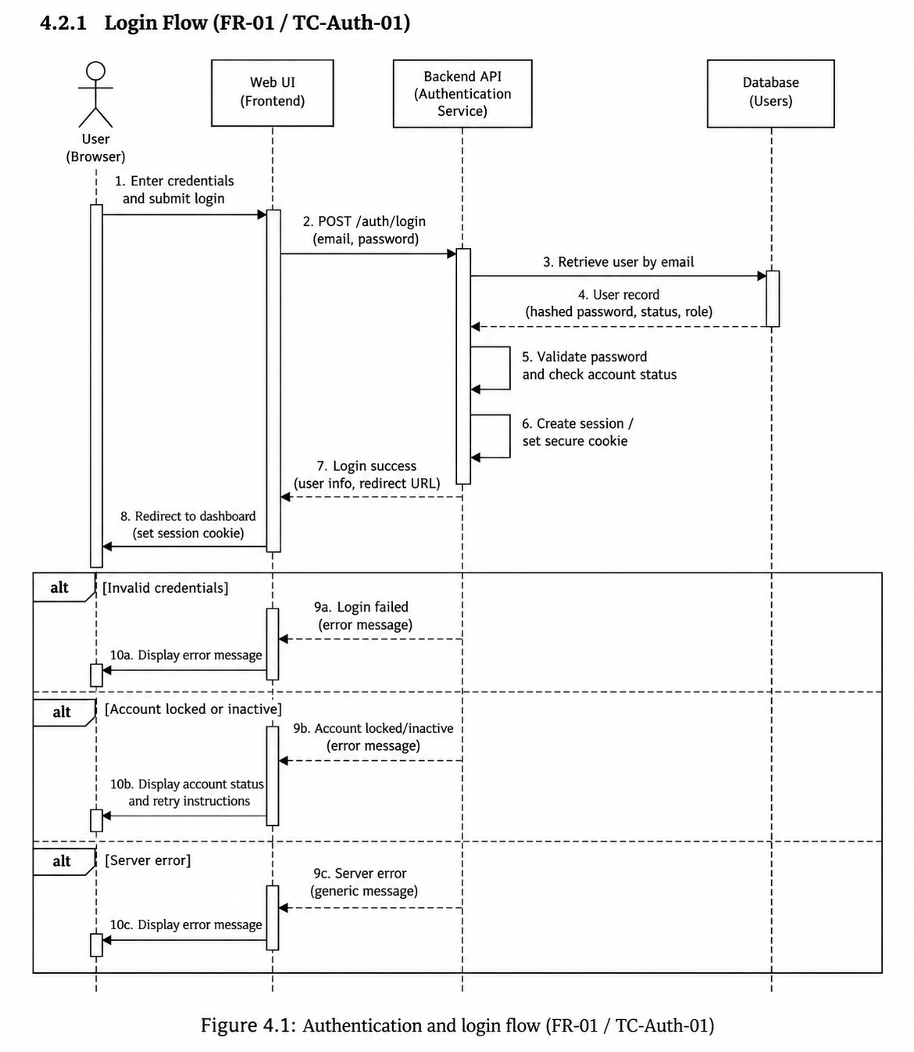

4.2.2 Create project flow (FR-05 / TC-Proj-01)
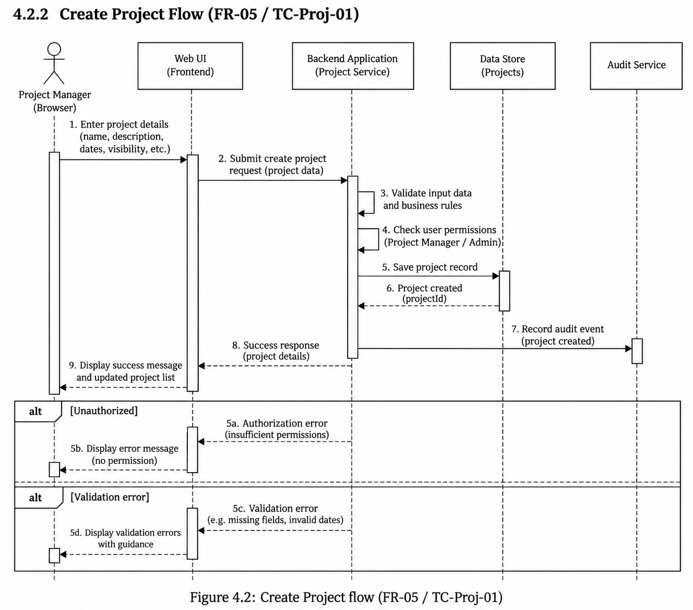

4.2.3 Task status update flow (FR-12 / TC-Task-05)
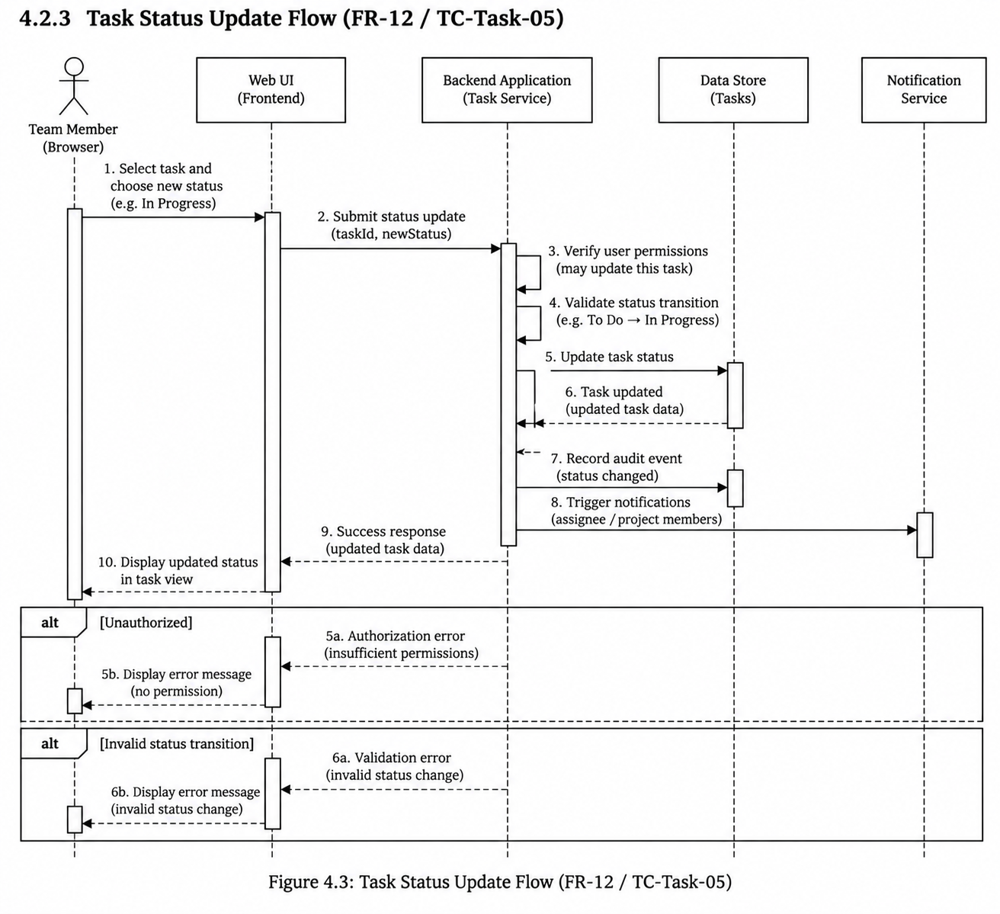

4.3 API / Interface Design
The SRS specifies browser-to-backend communication but does not define endpoint names, payload formats, or HTTP status codes. The following are illustrative interface contracts to guide implementation; confirm them with the selected stack and record final contracts in the implementation documentation.
Illustrative operation | Input | Successful result | Key checks / linked test
POST /auth/login | Credentials supplied by the login form. | Authenticated session or equivalent session token. | Valid/invalid credentials; TC-Auth-01, TC-Sec-01/02.
POST /auth/logout | Current authenticated session. | Session invalidated. | Protected routes require re-authentication; TC-Auth-02, TC-Sec-04.
POST /projects | Required basic project details. | Created project identifier and saved details. | Project Manager authorization and input validation; TC-Proj-01.
PATCH /projects/{id} | Editable project fields. | Updated project details. | Authorization and persistence; TC-Proj-02.
POST /projects/{id}/members | Member identifier and any supported membership details. | Updated membership list. | Only authorized project management; TC-Proj-03.
POST /projects/{id}/tasks | Task details and project association. | Created task identifier and details. | Project access and required-field validation; TC-Task-01.
PATCH /tasks/{id}/status | One allowed status: To Do, In Progress, Completed. | Updated task status. | Permission and valid status; TC-Task-05.

4.4 Error Handling, Logging and Monitoring
- Validate required fields and reject invalid values without silently saving partial or inconsistent data.
- Return clear, consistent error feedback for invalid credentials, missing required data, unauthorized actions, and unavailable records.
- A failed operation must not discard previously saved project or task data; verify with TC-Rel-02.
- Log important user, project, and task actions for accountability; verify with TC-Sec-05.
- Do not log passwords, password hashes, session secrets, or sensitive authentication values.
- The SRS does not specify a monitoring platform or numeric uptime target; these should not be treated as fixed requirements unless separately agreed.

4.5 UX Design
•Responsive layouts for desktop, tablet and mobile browser viewports. • Role-aware navigation: Team Members, Project Managers and Administrators see only relevant functions, Admin user management, and basic reports. Use clear and consistent navigation, understandable validation/error messages, and consistent presentation of project/task status. Verify core-workflow clarity through TC-UX-01.

4.6 Data Design (logical)
Logical entity | Core purpose / relationships
User | Account identity, role, and authentication-related fields; password stored as a hash, not plaintext.
Project | Project details and project-level metadata; associated with Project Manager/authorized members.
Project Membership | Associates users with projects and supports add/remove membership operations.
Task | Belongs to a project; may have an assignee, priority, deadline, status, and comments.
Milestone | Belongs to a project and records milestone details, status, and progress.
Comment | Belongs to a task and records comment content and author.
Audit Log | Records important user, project, and task actions for accountability.

These are logical entities inferred from the SRS feature set, not a finalized MongoDB schema. Collection names, field types, validation rules, and indexes remain implementation decisions.

4.7 Open Issues and Next Steps
- Confirm the frontend and backend frameworks and exact API contracts.
- Finalize the DB document/collection model and validation strategy.
- Review the standalone Test Plan and align each detailed test step with the SRS test IDs.
- Add finalized component/use-case diagrams if required by the assessment submission format.
- Keep this document synchronized with implementation changes and record significant design decisions.

5. Quality Requirements and Verification
Requirement | Design response | Verification reference
PMS-NFR-001 Security (High) | Authentication and role-based access protect restricted features. | TC-Sec-01; TC-Auth-03
PMS-NFR-002 Availability (Medium) | System should support normal project-management use except planned maintenance. | TC-Rel-01
PMS-NFR-003 Usability (Medium) | Clear and consistent screens support core workflows. | TC-UX-01
PMS-NFR-004 Maintainability (Medium) | Modular components and maintained basic documentation. | TC-Maint-01
PMS-NFR-005 Reliability (High) | Saved project/task data is retained correctly and common errors do not discard saved data. | TC-Rel-02

5.1 Security Objectives
ID | Objective | Design implication
SO-01 | Protect Data | Prevent unauthorized access to or modification of user and project information.
SO-02 | Authorized Actions and Accountability | Enforce role permissions and record important system activities in audit logs.

5.2 Security Requirements
ID | Requirement | Verification
PMS-SR-001 | Protected features require authenticated users. | TC-Sec-01
PMS-SR-002 | Passwords are stored only in hashed form. | TC-Sec-02
PMS-SR-003 | Admin, Project Manager, and Team Member permissions are enforced. | TC-Sec-03
PMS-SR-004 | Logout invalidates the user's authenticated session. | TC-Sec-04
PMS-SR-005 | Important user, project, and task actions are recorded in audit logs. | TC-Sec-05

5.3 Acceptance / Exit Criteria
- Verify the high-priority functional requirements and execute the applicable requirement-linked tests.
- Review all five NFRs and their linked test cases.
- Verify both security objectives and all five security requirements.
- No critical defects remain in the core workflows before acceptance.
- Update the RTM/test evidence with actual outcomes; this SAD does not claim tests have been executed.

6. Requirements Traceability Matrix
Req ID | Requirement | Design component | Test case
PMS-FR-01 | User Login | Authentication / Session | TC-Auth-01
PMS-FR-02 | User Logout | Authentication / Session | TC-Auth-02
PMS-FR-03 | Role-Based Access Control | RBAC / Authorization | TC-Auth-03
PMS-FR-04 | User Management | User Management | TC-User-01
PMS-FR-05 | Create Project | Project Management | TC-Proj-01
PMS-FR-06 | Edit Project | Project Management | TC-Proj-02
PMS-FR-07 | Manage Project Members | Project Management / RBAC | TC-Proj-03
PMS-FR-08 | Create Task | Task Management | TC-Task-01
PMS-FR-09 | Assign Task | Task Management / RBAC | TC-Task-02
PMS-FR-10 | Manage Task Priority | Task Management | TC-Task-03
PMS-FR-11 | Manage Task Deadline | Task Management | TC-Task-04
PMS-FR-12 | Update Task Status | Task Management | TC-Task-05
PMS-FR-13 | Add Task Comments | Comments / Task Management | TC-Task-06
PMS-FR-14 | Create and Edit Milestones | Milestone Management | TC-Mile-01
PMS-FR-15 | Track Milestones | Milestone Management | TC-Mile-02
PMS-FR-16 | View Project Dashboard | Dashboard | TC-Dash-01
PMS-FR-17 | View Basic Project Report | Reporting | TC-Report-01

Req ID | Requirement | Design response | Test case
PMS-NFR-001 | Security | Authentication and RBAC on restricted features | TC-Sec-01
PMS-NFR-002 | Availability | Normal project-management use except planned maintenance | TC-Rel-01
PMS-NFR-003 | Usability | Clear and consistent core-workflow screens | TC-UX-01
PMS-NFR-004 | Maintainability | Modular components and basic documentation | TC-Maint-01
PMS-NFR-005 | Reliability | Preserve saved project/task data through common errors | TC-Rel-02
PMS-SR-001 | Authentication | Require authenticated users for protected features | TC-Sec-01
PMS-SR-002 | Password Storage | Hash passwords before storage | TC-Sec-02
PMS-SR-003 | Role-Based Access | Enforce Admin / Project Manager / Team Member permissions | TC-Sec-03
PMS-SR-004 | Logout | Invalidate the authenticated session | TC-Sec-04
PMS-SR-005 | Audit Logs | Record important user, project, and task actions | TC-Sec-05

Status note: the SRS RTM marks requirements as not yet implemented/verified in its source document. Update statuses only after implementation and test evidence are available.

7. Appendices

7.1 Glossary
PMS — Project Management System; RBAC — Role-Based Access Control; CRUD — Create, Read, Update, Delete; RTM — Requirements Traceability Matrix; UI — User Interface; API — Application Programming Interface; DB — Database.

7.2 Source Basis and Limitations
This SAD is tailored to the PMS SRS supplied in the project library. It uses the SRS functional/non-functional/security requirements and their associated test-case identifiers. A separate detailed Test Plan document was not available among the accessible source files during preparation; therefore, test IDs are mapped as stated in the SRS and detailed test steps have not been invented. API routes and logical data entities are illustrative design proposals, not requirements explicitly mandated by the SRS.

7.3 Suggested Tools
Use a UML/component diagram tool such as draw.io or PlantUML for finalized diagrams, Git/GitHub for source and change history, and GitHub Actions for automated build/test checks once the implementation stack and commands are selected.

